Load the Dataset
from google.colab import drive
drive.mount('/content/gdrive/',force_remount=True)
Mounted at /content/gdrive/
import os
path = "/content/gdrive/MyDrive/Final_Project_Quant"
os.chdir(path)
!pip install prince
Requirement already satisfied: prince in /usr/local/lib/python3.10/dist-packages (0.11.0)
Requirement already satisfied: altair<6.0.0,>=4.2.2 in /usr/local/lib/python3.10/dist-packages (from prince) (4.2.2)
Requirement already satisfied: pandas<3.0.0,>=1.4.1 in /usr/local/lib/python3.10/dist-packages (from prince) (1.5.3)
Requirement already satisfied: scikit-learn<2.0.0,>=1.0.2 in /usr/local/lib/python3.10/dist-packages (from prince) (1.2.2)
Requirement already satisfied: entrypoints in /usr/local/lib/python3.10/dist-packages (from altair<6.0.0,>=4.2.2->prince) (0.4)
Requirement already satisfied: jinja2 in /usr/local/lib/python3.10/dist-packages (from altair<6.0.0,>=4.2.2->prince) (3.1.2)
Requirement already satisfied: jsonschema>=3.0 in /usr/local/lib/python3.10/dist-packages (from altair<6.0.0,>=4.2.2->prince) (4.3.3)
Requirement already satisfied: numpy in /usr/local/lib/python3.10/dist-packages (from altair<6.0.0,>=4.2.2->prince) (1.25.2)
Requirement already satisfied: toolz in /usr/local/lib/python3.10/dist-packages (from altair<6.0.0,>=4.2.2->prince) (0.12.0)
Requirement already satisfied: python-dateutil>=2.8.1 in /usr/local/lib/python3.10/dist-packages (from pandas<3.0.0,>=1.4.1->prince) (2.8.2)
Requirement already satisfied: pytz>=2020.1 in /usr/local/lib/python3.10/dist-packages (from pandas<3.0.0,>=1.4.1->prince) (2022.7.1)
Requirement already satisfied: scipy>=1.3.2 in /usr/local/lib/python3.10/dist-packages (from scikit-learn<2.0.0,>=1.0.2->prince) (1.10.1)
Requirement already satisfied: joblib>=1.1.1 in /usr/local/lib/python3.10/dist-packages (from scikit-learn<2.0.0,>=1.0.2->prince) (1.3.1)
Requirement already satisfied: threadpoolctl>=2.0.0 in /usr/local/lib/python3.10/dist-packages (from scikit-learn<2.0.0,>=1.0.2->prince) (3.2.0)
Requirement already satisfied: attrs>=17.4.0 in /usr/local/lib/python3.10/dist-packages (from jsonschema>=3.0->altair<6.0.0,>=4.2.2->prince) (23.1.0)
Requirement already satisfied: pyrsistent!=0.17.0,!=0.17.1,!=0.17.2,>=0.14.0 in /usr/local/lib/python3.10/dist-packages (from jsonschema>=3.0->altair<6.0.0,>=4.2.2->prince) (0.19.3)
Requirement already satisfied: six>=1.5 in /usr/local/lib/python3.10/dist-packages (from python-dateutil>=2.8.1->pandas<3.0.0,>=1.4.1->prince) (1.16.0)
Requirement already satisfied: MarkupSafe>=2.0 in /usr/local/lib/python3.10/dist-packages (from jinja2->altair<6.0.0,>=4.2.2->prince) (2.1.3)
!pip install yellowbrick
Requirement already satisfied: yellowbrick in /usr/local/lib/python3.10/dist-packages (1.5)
Requirement already satisfied: matplotlib!=3.0.0,>=2.0.2 in /usr/local/lib/python3.10/dist-packages (from yellowbrick) (3.7.1)
Requirement already satisfied: scipy>=1.0.0 in /usr/local/lib/python3.10/dist-packages (from yellowbrick) (1.10.1)
Requirement already satisfied: scikit-learn>=1.0.0 in /usr/local/lib/python3.10/dist-packages (from yellowbrick) (1.2.2)
Requirement already satisfied: numpy>=1.16.0 in /usr/local/lib/python3.10/dist-packages (from yellowbrick) (1.25.2)
Requirement already satisfied: cycler>=0.10.0 in /usr/local/lib/python3.10/dist-packages (from yellowbrick) (0.11.0)
Requirement already satisfied: contourpy>=1.0.1 in /usr/local/lib/python3.10/dist-packages (from matplotlib!=3.0.0,>=2.0.2->yellowbrick) (1.1.0)
Requirement already satisfied: fonttools>=4.22.0 in /usr/local/lib/python3.10/dist-packages (from matplotlib!=3.0.0,>=2.0.2->yellowbrick) (4.41.1)
Requirement already satisfied: kiwisolver>=1.0.1 in /usr/local/lib/python3.10/dist-packages (from matplotlib!=3.0.0,>=2.0.2->yellowbrick) (1.4.4)
Requirement already satisfied: packaging>=20.0 in /usr/local/lib/python3.10/dist-packages (from matplotlib!=3.0.0,>=2.0.2->yellowbrick) (23.1)
Requirement already satisfied: pillow>=6.2.0 in /usr/local/lib/python3.10/dist-packages (from matplotlib!=3.0.0,>=2.0.2->yellowbrick) (9.4.0)
Requirement already satisfied: pyparsing>=2.3.1 in /usr/local/lib/python3.10/dist-packages (from matplotlib!=3.0.0,>=2.0.2->yellowbrick) (3.1.0)
Requirement already satisfied: python-dateutil>=2.7 in /usr/local/lib/python3.10/dist-packages (from matplotlib!=3.0.0,>=2.0.2->yellowbrick) (2.8.2)
Requirement already satisfied: joblib>=1.1.1 in /usr/local/lib/python3.10/dist-packages (from scikit-learn>=1.0.0->yellowbrick) (1.3.1)
Requirement already satisfied: threadpoolctl>=2.0.0 in /usr/local/lib/python3.10/dist-packages (from scikit-learn>=1.0.0->yellowbrick) (3.2.0)
Requirement already satisfied: six>=1.5 in /usr/local/lib/python3.10/dist-packages (from python-dateutil>=2.7->matplotlib!=3.0.0,>=2.0.2->yellowbrick) (1.16.0)
!pip install pygam
Requirement already satisfied: pygam in /usr/local/lib/python3.10/dist-packages (0.9.0)
Requirement already satisfied: numpy<2.0.0,>=1.24.2 in /usr/local/lib/python3.10/dist-packages (from pygam) (1.25.2)
Requirement already satisfied: progressbar2<5.0.0,>=4.2.0 in /usr/local/lib/python3.10/dist-packages (from pygam) (4.2.0)
Requirement already satisfied: scipy<2.0.0,>=1.10.1 in /usr/local/lib/python3.10/dist-packages (from pygam) (1.10.1)
Requirement already satisfied: python-utils>=3.0.0 in /usr/local/lib/python3.10/dist-packages (from progressbar2<5.0.0,>=4.2.0->pygam) (3.7.0)
Requirement already satisfied: typing-extensions>3.10.0.2 in /usr/local/lib/python3.10/dist-packages (from python-utils>=3.0.0->progressbar2<5.0.0,>=4.2.0->pygam) (4.7.1)
!pip install dmba
Requirement already satisfied: dmba in /usr/local/lib/python3.10/dist-packages (0.2.4)
Requirement already satisfied: graphviz in /usr/local/lib/python3.10/dist-packages (from dmba) (0.20.1)
Requirement already satisfied: matplotlib in /usr/local/lib/python3.10/dist-packages (from dmba) (3.7.1)
Requirement already satisfied: numpy in /usr/local/lib/python3.10/dist-packages (from dmba) (1.25.2)
Requirement already satisfied: pandas in /usr/local/lib/python3.10/dist-packages (from dmba) (1.5.3)
Requirement already satisfied: scikit-learn in /usr/local/lib/python3.10/dist-packages (from dmba) (1.2.2)
Requirement already satisfied: scipy in /usr/local/lib/python3.10/dist-packages (from dmba) (1.10.1)
Requirement already satisfied: contourpy>=1.0.1 in /usr/local/lib/python3.10/dist-packages (from matplotlib->dmba) (1.1.0)
Requirement already satisfied: cycler>=0.10 in /usr/local/lib/python3.10/dist-packages (from matplotlib->dmba) (0.11.0)
Requirement already satisfied: fonttools>=4.22.0 in /usr/local/lib/python3.10/dist-packages (from matplotlib->dmba) (4.41.1)
Requirement already satisfied: kiwisolver>=1.0.1 in /usr/local/lib/python3.10/dist-packages (from matplotlib->dmba) (1.4.4)
Requirement already satisfied: packaging>=20.0 in /usr/local/lib/python3.10/dist-packages (from matplotlib->dmba) (23.1)
Requirement already satisfied: pillow>=6.2.0 in /usr/local/lib/python3.10/dist-packages (from matplotlib->dmba) (9.4.0)
Requirement already satisfied: pyparsing>=2.3.1 in /usr/local/lib/python3.10/dist-packages (from matplotlib->dmba) (3.1.0)
Requirement already satisfied: python-dateutil>=2.7 in /usr/local/lib/python3.10/dist-packages (from matplotlib->dmba) (2.8.2)
Requirement already satisfied: pytz>=2020.1 in /usr/local/lib/python3.10/dist-packages (from pandas->dmba) (2022.7.1)
Requirement already satisfied: joblib>=1.1.1 in /usr/local/lib/python3.10/dist-packages (from scikit-learn->dmba) (1.3.1)
Requirement already satisfied: threadpoolctl>=2.0.0 in /usr/local/lib/python3.10/dist-packages (from scikit-learn->dmba) (3.2.0)
Requirement already satisfied: six>=1.5 in /usr/local/lib/python3.10/dist-packages (from python-dateutil>=2.7->matplotlib->dmba) (1.16.0)
!pip install sktime
Requirement already satisfied: sktime in /usr/local/lib/python3.10/dist-packages (0.21.0)
Requirement already satisfied: deprecated>=1.2.13 in /usr/local/lib/python3.10/dist-packages (from sktime) (1.2.14)
Requirement already satisfied: numpy<1.26,>=1.21.0 in /usr/local/lib/python3.10/dist-packages (from sktime) (1.25.2)
Requirement already satisfied: pandas<2.1.0,>=1.1.0 in /usr/local/lib/python3.10/dist-packages (from sktime) (1.5.3)
Requirement already satisfied: packaging in /usr/local/lib/python3.10/dist-packages (from sktime) (23.1)
Requirement already satisfied: scikit-base<0.6.0 in /usr/local/lib/python3.10/dist-packages (from sktime) (0.5.0)
Requirement already satisfied: scikit-learn<1.4.0,>=0.24.0 in /usr/local/lib/python3.10/dist-packages (from sktime) (1.2.2)
Requirement already satisfied: scipy<2.0.0,>=1.2.0 in /usr/local/lib/python3.10/dist-packages (from sktime) (1.10.1)
Requirement already satisfied: wrapt<2,>=1.10 in /usr/local/lib/python3.10/dist-packages (from deprecated>=1.2.13->sktime) (1.14.1)
Requirement already satisfied: python-dateutil>=2.8.1 in /usr/local/lib/python3.10/dist-packages (from pandas<2.1.0,>=1.1.0->sktime) (2.8.2)
Requirement already satisfied: pytz>=2020.1 in /usr/local/lib/python3.10/dist-packages (from pandas<2.1.0,>=1.1.0->sktime) (2022.7.1)
Requirement already satisfied: joblib>=1.1.1 in /usr/local/lib/python3.10/dist-packages (from scikit-learn<1.4.0,>=0.24.0->sktime) (1.3.1)
Requirement already satisfied: threadpoolctl>=2.0.0 in /usr/local/lib/python3.10/dist-packages (from scikit-learn<1.4.0,>=0.24.0->sktime) (3.2.0)
Requirement already satisfied: six>=1.5 in /usr/local/lib/python3.10/dist-packages (from python-dateutil>=2.8.1->pandas<2.1.0,>=1.1.0->sktime) (1.16.0)
import math
import pandas as pd
import numpy as np
import matplotlib.pyplot as plt
import statsmodels.api as sm
import statsmodels.formula.api as smf
import patsy
import prince
import seaborn as sns
from pathlib import Path
from statsmodels.stats.outliers_influence import OLSInfluence
from pygam import LinearGAM, s, l
from pygam.datasets import wage
from dmba import stepwise_selection
from dmba import AIC_score
from sklearn.metrics import precision_recall_fscore_support
from sklearn.model_selection import train_test_split
from sklearn.linear_model import LogisticRegression, LinearRegression #, LogisticRegressionCV
from sklearn.tree import DecisionTreeClassifier
from sklearn.preprocessing import OrdinalEncoder
from sklearn.preprocessing import LabelEncoder
from sklearn.metrics import mean_absolute_error,classification_report, mean_squared_error, r2_score, accuracy_score, precision_score, recall_score, f1_score, roc_curve, roc_auc_score, confusion_matrix
from scipy import stats
from sklearn.tree import plot_tree
from sklearn import preprocessing
from sklearn.decomposition import PCA
from sklearn.cluster import KMeans
from sklearn.mixture import GaussianMixture
from scipy.cluster.hierarchy import linkage, dendrogram, fcluster
from scipy.stats import multivariate_normal
from matplotlib import cm
from matplotlib.colors import from_levels_and_colors
from statsmodels.stats import power
import matplotlib.pyplot as plt
plt.rcParams['lines.linewidth'] = 3
plt.rcParams['figure.figsize'] = [14.0, 6.0]
plt.rcParams['font.size']= 18
plt.style.available # Check what styles are available for Chart formats by visiting : https://matplotlib.org/stable/gallery/style_sheets/style_sheets_reference.html
plt.style.use('fivethirtyeight') # Assigning the FiveThirtyEight format, you can choose any of the names from the above link
# loading the dataset
crop_recom=pd.read_csv("Crop_recommendation.csv")
#Finding more information on the dataset
crop_recom.info()
<class 'pandas.core.frame.DataFrame'>
RangeIndex: 2200 entries, 0 to 2199
Data columns (total 8 columns):
# Column Non-Null Count Dtype
--- ------ -------------- -----
0 N 2200 non-null int64
1 P 2200 non-null int64
2 K 2200 non-null int64
3 temperature 2200 non-null float64
4 humidity 2200 non-null float64
5 ph 2200 non-null float64
6 rainfall 2200 non-null float64
7 label 2200 non-null object
dtypes: float64(4), int64(3), object(1)
memory usage: 137.6+ KB
crop_recom.describe()
N P K temperature humidity \
count 2200.000000 2200.000000 2200.000000 2200.000000 2200.000000
mean 50.551818 53.362727 48.149091 25.616244 71.481779
std 36.917334 32.985883 50.647931 5.063749 22.263812
min 0.000000 5.000000 5.000000 8.825675 14.258040
25% 21.000000 28.000000 20.000000 22.769375 60.261953
50% 37.000000 51.000000 32.000000 25.598693 80.473146
75% 84.250000 68.000000 49.000000 28.561654 89.948771
max 140.000000 145.000000 205.000000 43.675493 99.981876
ph rainfall
count 2200.000000 2200.000000
mean 6.469480 103.463655
std 0.773938 54.958389
min 3.504752 20.211267
25% 5.971693 64.551686
50% 6.425045 94.867624
75% 6.923643 124.267508
max 9.935091 298.560117
crop_recom['label'].unique()
array(['rice', 'maize', 'chickpea', 'kidneybeans', 'pigeonpeas',
'mothbeans', 'mungbean', 'blackgram', 'lentil', 'pomegranate',
'banana', 'mango', 'grapes', 'watermelon', 'muskmelon', 'apple',
'orange', 'papaya', 'coconut', 'cotton', 'jute', 'coffee'],
dtype=object)
crop_recom.isnull().sum()
N 0
P 0
K 0
temperature 0
humidity 0
ph 0
rainfall 0
label 0
dtype: int64
crop_recom.head()
N P K temperature humidity ph rainfall label
0 90 42 43 20.879744 82.002744 6.502985 202.935536 rice
1 85 58 41 21.770462 80.319644 7.038096 226.655537 rice
2 60 55 44 23.004459 82.320763 7.840207 263.964248 rice
3 74 35 40 26.491096 80.158363 6.980401 242.864034 rice
4 78 42 42 20.130175 81.604873 7.628473 262.717340 rice
# Loading the dataset as X and Y
X=crop_recom[['N','P','K','temperature','humidity','ph','rainfall']]
y=crop_recom['label']
sns.pairplot(data=crop_recom,hue='label',palette='viridis')
<seaborn.axisgrid.PairGrid at 0x7ccb7b765870>
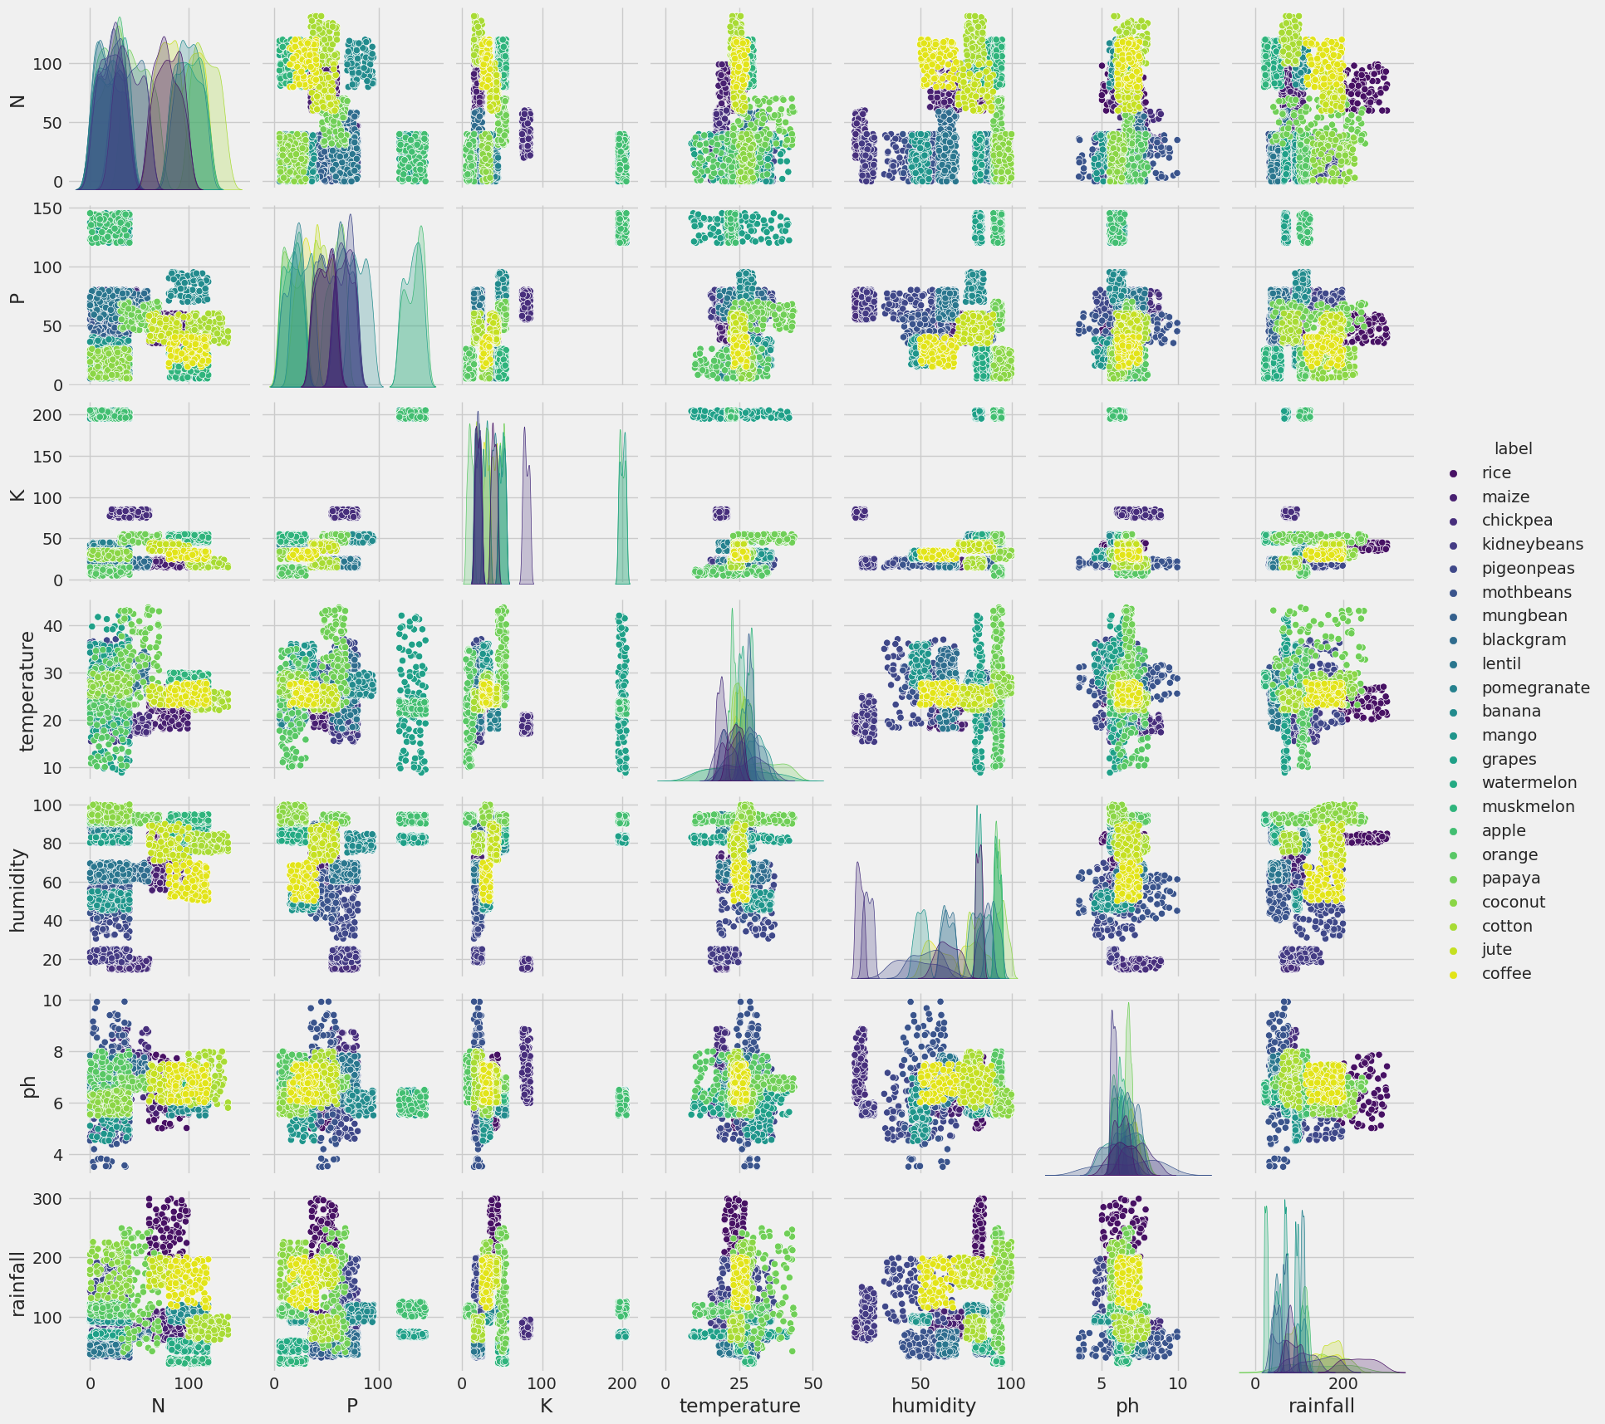
sns.heatmap(crop_recom.corr(), linecolor='white', linewidths=1,annot=True)
<ipython-input-261-260999dfce60>:1: FutureWarning: The default value of numeric_only in DataFrame.corr is deprecated. In a future version, it will default to False. Select only valid columns or specify the value of numeric_only to silence this warning.
sns.heatmap(crop_recom.corr(), linecolor='white', linewidths=1,annot=True)
<Axes: >
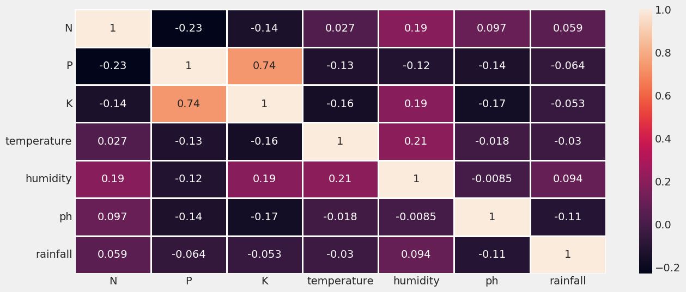
# Split the dataset into training and testing sets
X_train, X_test, y_train, y_test = train_test_split(X, y, test_size=0.3, random_state=0)

Decision Tree Model
# Build the Decision Tree model
decision_tree = DecisionTreeClassifier(criterion="entropy",random_state=2,max_depth=5)
decision_tree.fit(X_train, y_train)
# Evaluate the model
print('Accuracy_decision_tree:', decision_tree.score(X_test, y_test))
# Predict the labels of the test set
y_pred_decision_tree = decision_tree.predict(X_test)
# Calculate the accuracy of the model
score_test_decision_tree = decision_tree.score(X_test, y_test)
score_train_decision_tree = decision_tree.score(X_train, y_train)
#Printing the Accuracy of the model
print("Accuracy Train_decision_tree:", score_train_decision_tree)
print("Accuracy Test_decision_tree:", score_test_decision_tree)
#print("Predictions_decision_tree:", y_pred_decision_tree)
print(classification_report(y_test,y_pred_decision_tree))
Accuracy_decision_tree: 0.9121212121212121
Accuracy Train_decision_tree: 0.9311688311688312
Accuracy Test_decision_tree: 0.9121212121212121
precision recall f1-score support
apple 1.00 1.00 1.00 28
banana 1.00 1.00 1.00 30
blackgram 0.65 1.00 0.78 31
chickpea 1.00 1.00 1.00 34
coconut 1.00 1.00 1.00 26
coffee 1.00 0.90 0.95 29
cotton 1.00 1.00 1.00 28
grapes 1.00 1.00 1.00 30
jute 1.00 0.23 0.37 31
kidneybeans 1.00 0.81 0.89 26
lentil 0.88 1.00 0.94 22
maize 0.71 0.81 0.76 27
mango 1.00 0.93 0.96 28
mothbeans 1.00 0.50 0.67 36
mungbean 0.94 1.00 0.97 29
muskmelon 0.97 1.00 0.98 30
orange 1.00 1.00 1.00 34
papaya 0.95 1.00 0.97 39
pigeonpeas 0.93 1.00 0.97 28
pomegranate 1.00 1.00 1.00 32
rice 0.63 1.00 0.77 37
watermelon 1.00 0.96 0.98 25
accuracy 0.91 660
macro avg 0.94 0.92 0.91 660
weighted avg 0.94 0.91 0.90 660
# Calculate the confusion matrix
cm_decision_tress = confusion_matrix(y_test, y_pred_decision_tree)
# Calculate the precision, recall, and accuracy
precision_decision_tress = precision_score(y_test, y_pred_decision_tree, average='macro')
recall_decision_tress = recall_score(y_test, y_pred_decision_tree, average='macro')
accuracy_decision_tress = accuracy_score(y_test, y_pred_decision_tree)
# Print the confusion matrix, precision, recall, and accuracy
print('Confusion Matrix_decision_tress:\n', cm_decision_tress)
print('Precision_decision_tress:', precision_decision_tress)
print('Recall_decision_tress:', recall_decision_tress)
print('Accuracy_decision_tress:', accuracy_decision_tress)
Confusion Matrix_decision_tress:
[[28 0 0 0 0 0 0 0 0 0 0 0 0 0 0 0 0 0 0 0 0 0]
[ 0 30 0 0 0 0 0 0 0 0 0 0 0 0 0 0 0 0 0 0 0 0]
[ 0 0 31 0 0 0 0 0 0 0 0 0 0 0 0 0 0 0 0 0 0 0]
[ 0 0 0 34 0 0 0 0 0 0 0 0 0 0 0 0 0 0 0 0 0 0]
[ 0 0 0 0 26 0 0 0 0 0 0 0 0 0 0 0 0 0 0 0 0 0]
[ 0 0 0 0 0 26 0 0 0 0 0 3 0 0 0 0 0 0 0 0 0 0]
[ 0 0 0 0 0 0 28 0 0 0 0 0 0 0 0 0 0 0 0 0 0 0]
[ 0 0 0 0 0 0 0 30 0 0 0 0 0 0 0 0 0 0 0 0 0 0]
[ 0 0 0 0 0 0 0 0 7 0 0 0 0 0 0 0 0 2 0 0 22 0]
[ 0 0 0 0 0 0 0 0 0 21 0 5 0 0 0 0 0 0 0 0 0 0]
[ 0 0 0 0 0 0 0 0 0 0 22 0 0 0 0 0 0 0 0 0 0 0]
[ 0 0 3 0 0 0 0 0 0 0 0 22 0 0 2 0 0 0 0 0 0 0]
[ 0 0 0 0 0 0 0 0 0 0 0 0 26 0 0 0 0 0 2 0 0 0]
[ 0 0 14 0 0 0 0 0 0 0 3 1 0 18 0 0 0 0 0 0 0 0]
[ 0 0 0 0 0 0 0 0 0 0 0 0 0 0 29 0 0 0 0 0 0 0]
[ 0 0 0 0 0 0 0 0 0 0 0 0 0 0 0 30 0 0 0 0 0 0]
[ 0 0 0 0 0 0 0 0 0 0 0 0 0 0 0 0 34 0 0 0 0 0]
[ 0 0 0 0 0 0 0 0 0 0 0 0 0 0 0 0 0 39 0 0 0 0]
[ 0 0 0 0 0 0 0 0 0 0 0 0 0 0 0 0 0 0 28 0 0 0]
[ 0 0 0 0 0 0 0 0 0 0 0 0 0 0 0 0 0 0 0 32 0 0]
[ 0 0 0 0 0 0 0 0 0 0 0 0 0 0 0 0 0 0 0 0 37 0]
[ 0 0 0 0 0 0 0 0 0 0 0 0 0 0 0 1 0 0 0 0 0 24]]
Precision_decision_tress: 0.9386549113061836
Recall_decision_tress: 0.9151562148558813
Accuracy_decision_tress: 0.9121212121212121
# Visualize the Decision Tree
plt.figure(figsize=(15, 10))
plot_tree(decision_tree, feature_names=X_train.columns, class_names=True, filled=True, rounded=True)
plt.show()
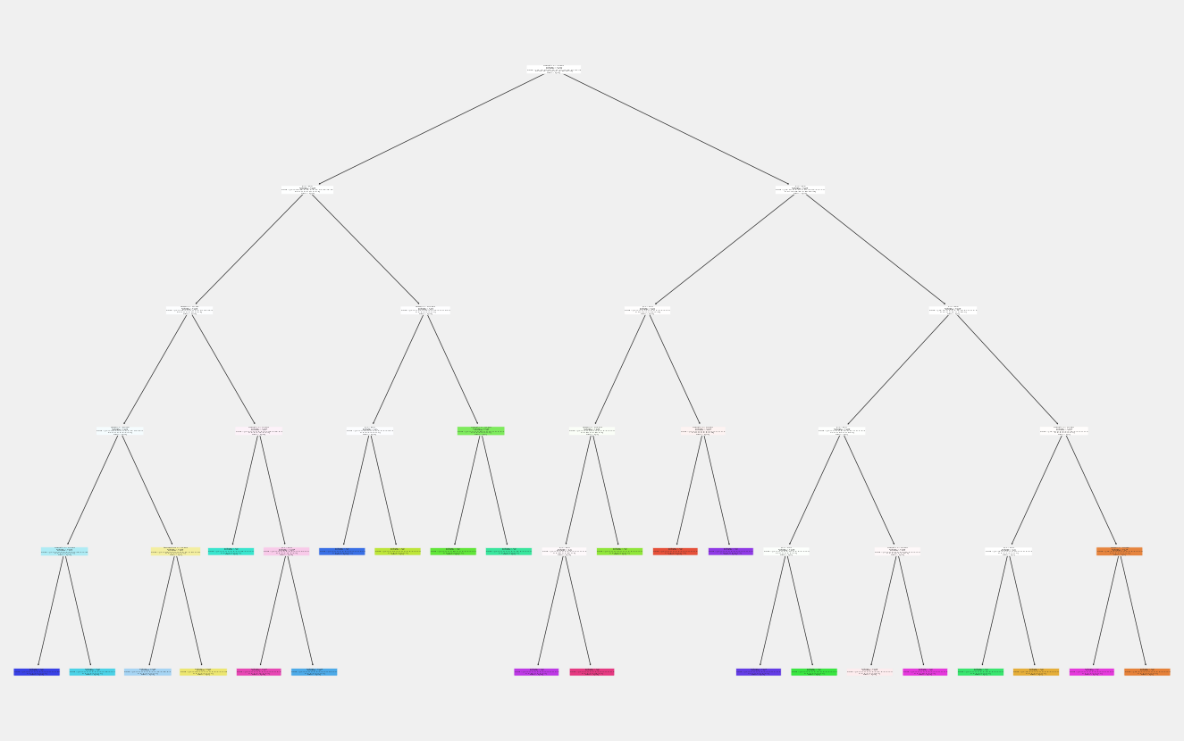
from sklearn.tree import DecisionTreeClassifier, export_graphviz
import graphviz
# Export the Decision Tree to DOT format
dot_data = export_graphviz(decision_tree, out_file=None,
feature_names=X_train.columns,
class_names=True, filled=True, rounded=True, special_characters=True)
# Visualize the Decision Tree using Graphviz
graph = graphviz.Source(dot_data)
graph = graphviz.Source(dot_data, format="png")
graph
#graph.render("decision_tree") # Save the visualization to a file (optional)
#graph.view() # Show the visualization in your default image viewer

K-Nearest Neighbour Model
#Let's convert the labels(type of crop) to binary
le = LabelEncoder()
y_encoded = le.fit_transform(crop_recom['label'].values)
print(y_encoded)
print(np.unique(y_encoded)) #Checking unique labels
[20 20 20 ... 5 5 5]
[ 0 1 2 3 4 5 6 7 8 9 10 11 12 13 14 15 16 17 18 19 20 21]
#Conversting back to the original
y_original = le.inverse_transform(y_encoded)
print(y_original)
['rice' 'rice' 'rice' ... 'coffee' 'coffee' 'coffee']
from sklearn.neighbors import KNeighborsClassifier
# Split the dataset into training and testing sets
X_train, X_test, y_train, y_test = train_test_split(X, y_encoded, test_size=0.35, random_state=42)
# Create a KNN classifier object : this is using a initial guess of k=2 neighbors, you can choose any small number
knn = KNeighborsClassifier(n_neighbors=20)
# Train the classifier on the training set
knn.fit(X_train, y_train)
# Predict the labels of the test set
y_pred = knn.predict(X_test)
# Print the accuracy of the classifier
print('Accuracy:', knn.score(X_test, y_test))
Accuracy: 0.951948051948052
# Now it’s time to improve the model and find out the OPTIMAL k value.
error_rate = []
for i in range(1,40):
knn = KNeighborsClassifier(n_neighbors=i)
knn.fit(X_train,y_train)
pred_i = knn.predict(X_test)
error_rate.append(np.mean(pred_i != y_test))
plt.figure(figsize=(20,6))
plt.plot(range(1,40),error_rate,color='blue', linestyle='dashed', marker='o',markerfacecolor='red', markersize=10)
plt.title('Error Rate vs. K Value')
plt.xlabel('K')
plt.ylabel('Error Rate')
print("Minimum error:-",min(error_rate),"at K =",error_rate.index(min(error_rate))+1)
Minimum error:- 0.024675324675324677 at K = 5
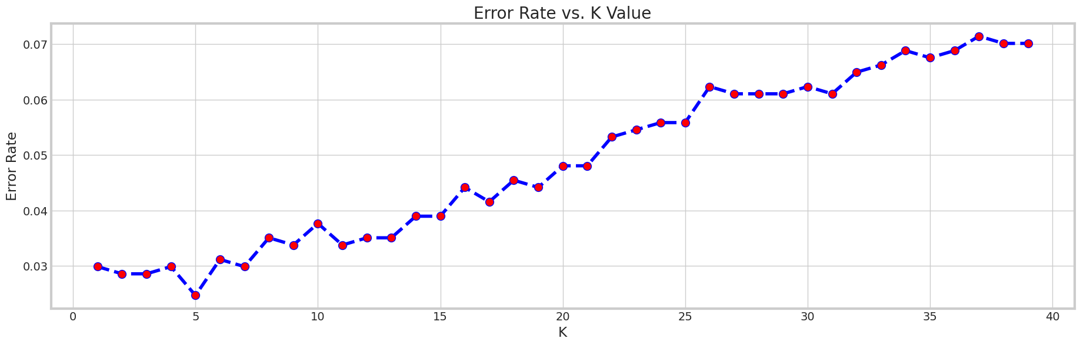
acc = []
# Will take some time
from sklearn import metrics
for i in range(1,40):
neigh = KNeighborsClassifier(n_neighbors = i).fit(X_train,y_train)
yhat = neigh.predict(X_test)
acc.append(metrics.accuracy_score(y_test, yhat))
plt.figure(figsize=(10,6))
plt.plot(range(1,40),acc,color = 'blue',linestyle='dashed', marker='o',markerfacecolor='red', markersize=10)
plt.title('accuracy vs. K Value')
plt.xlabel('K')
plt.ylabel('Accuracy')
print("Maximum accuracy:-",max(acc),"at K =",acc.index(max(acc))+1)
Maximum accuracy:- 0.9753246753246754 at K = 5
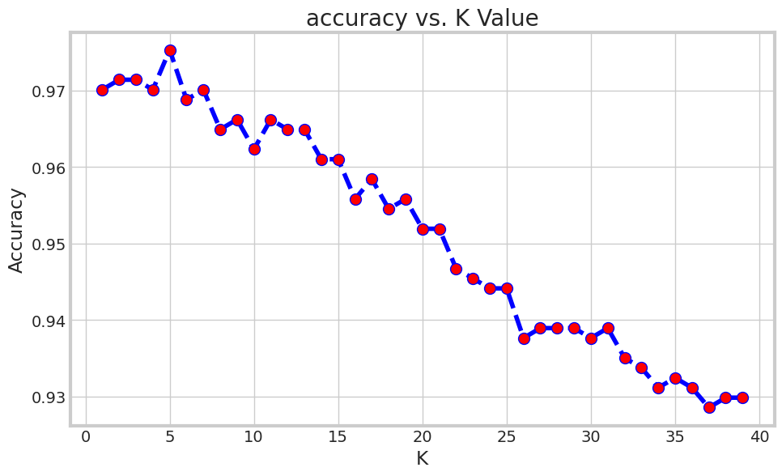
## So we will retrain the model with k=5
knn = KNeighborsClassifier(n_neighbors=5)
# Train the classifier on the training set
knn.fit(X_train, y_train)
# Predict the labels of the test set
y_pred_knn = knn.predict(X_test)
# Print the accuracy of the classifier
print('Accuracy_knn:', knn.score(X_test, y_test))
# Calculate the accuracy of the model
score_train_knn = knn.score(X_train, y_train)
score_test_knn = knn.score(X_test, y_test)
print("Accuracy Train_knn:", score_train_knn)
print("Accuracy Test_knn:", score_test_knn)
#print("Predictions_knn:", y_pred_knn) # you can remove the comment and see the predictions
Accuracy_knn: 0.9753246753246754
Accuracy Train_knn: 0.9888111888111888
Accuracy Test_knn: 0.9753246753246754
# Calculate the confusion matrix
cm_knn = confusion_matrix(y_test, y_pred_knn)
# Calculate the precision, recall, and accuracy
precision_knn = precision_score(y_test, y_pred_knn, average='macro')
recall_knn = recall_score(y_test, y_pred_knn, average='macro')
accuracy_knn = accuracy_score(y_test, y_pred_knn)
# Print the confusion matrix, precision, recall, and accuracy
print('Confusion Matrix_lm:\n', cm_knn)
print('Precision_knn:', precision_knn)
print('Recall_knn:', recall_knn)
print('Accuracy_knn:', accuracy_knn)
Confusion Matrix_lm:
[[42 0 0 0 0 0 0 0 0 0 0 0 0 0 0 0 0 0 0 0 0 0]
[ 0 32 0 0 0 0 0 0 0 0 0 0 0 0 0 0 0 0 0 0 0 0]
[ 0 0 30 0 0 0 0 0 0 0 0 0 0 0 0 0 0 0 0 0 0 0]
[ 0 0 0 42 0 0 0 0 0 0 0 0 0 0 0 0 0 0 0 0 0 0]
[ 0 0 0 0 36 0 0 0 0 0 0 0 0 0 0 0 0 0 0 0 0 0]
[ 0 0 0 0 0 33 0 0 1 0 0 0 0 0 0 0 0 0 0 0 0 0]
[ 0 0 0 0 0 0 34 0 0 0 0 0 0 0 0 0 0 0 0 0 0 0]
[ 0 0 0 0 0 0 0 29 0 0 0 0 0 0 0 0 0 0 0 0 0 0]
[ 0 0 0 0 0 0 0 0 35 0 0 0 0 0 0 0 0 0 0 0 2 0]
[ 0 0 0 0 0 0 0 0 0 41 0 0 0 0 0 0 0 0 0 0 0 0]
[ 0 0 0 0 0 0 0 0 0 0 30 0 0 1 0 0 0 0 0 0 0 0]
[ 0 0 0 0 0 0 2 0 0 0 0 33 0 0 0 0 0 0 0 0 0 0]
[ 0 0 0 0 0 0 0 0 0 0 0 0 37 0 0 0 0 0 0 0 0 0]
[ 0 0 0 0 0 0 0 0 0 0 2 0 0 38 0 0 0 0 0 0 0 0]
[ 0 0 0 0 0 0 0 0 0 0 0 0 0 0 34 0 0 0 0 0 0 0]
[ 0 0 0 0 0 0 0 0 0 0 0 0 0 0 0 28 0 0 0 0 0 0]
[ 0 0 0 0 0 0 0 0 0 0 0 0 0 0 0 0 29 0 0 0 0 0]
[ 0 0 0 0 0 0 0 0 0 0 0 0 0 0 0 0 0 39 0 0 0 0]
[ 0 0 1 0 0 0 0 0 0 4 0 0 0 0 0 0 0 0 38 0 0 0]
[ 0 0 0 0 0 0 0 0 0 0 0 0 0 0 0 0 0 0 0 41 0 0]
[ 0 0 0 0 0 0 0 0 6 0 0 0 0 0 0 0 0 0 0 0 25 0]
[ 0 0 0 0 0 0 0 0 0 0 0 0 0 0 0 0 0 0 0 0 0 25]]
Precision_knn: 0.9770188965753482
Recall_knn: 0.975786627396221
Accuracy_knn: 0.9753246753246754
####################################
# ROC Curve Construction
####################################
# compute TPR = True Positive Rate and FPR=False Positive Rate for various thresholds
# Binarize the output
y_test_bin_knn = label_binarize(y_test, classes=[0 ,1 ,2 ,3 ,4 ,5 ,6 ,7 ,8 ,9 ,10 ,11 ,12 ,13 ,14 ,15 ,16 ,17 ,18 ,19 ,20 ,21])
y_pred_bin_knn= label_binarize(y_pred_knn, classes=[0 ,1 ,2 ,3 ,4 ,5 ,6 ,7 ,8 ,9 ,10 ,11 ,12 ,13 ,14 ,15 ,16 ,17 ,18 ,19 ,20 ,21])
# compute ROC curve and AUC for each class
fpr = dict()
tpr = dict()
roc_auc = dict()
num_classes = y_test_bin_knn.shape[1] # Get the number of classes in your problem
for i in range(num_classes):
fpr[i], tpr[i], _ = roc_curve(y_test_bin_knn[:, i], y_pred_bin_knn[:, i])
roc_auc[i] = auc(fpr[i], tpr[i])
# plot ROC curves
plt.figure()
for i in range(num_classes):
plt.plot(fpr[i], tpr[i], label='Class %d (AUC = %0.2f)' % (i, roc_auc[i]))
plt.plot([0, 1], [0, 1], 'k--') # diagonal line for reference
plt.xlim([0.0, 1.0])
plt.ylim([0.0, 1.05])
plt.xlabel('False Positive Rate')
plt.ylabel('True Positive Rate')
plt.title('ROC Curves - Crop Recommendation- KNN model')
plt.legend(loc="lower right")
plt.show()
# The ROC curve below shows a near perfect model since the Blue ROC curve is almost touching the top left corner
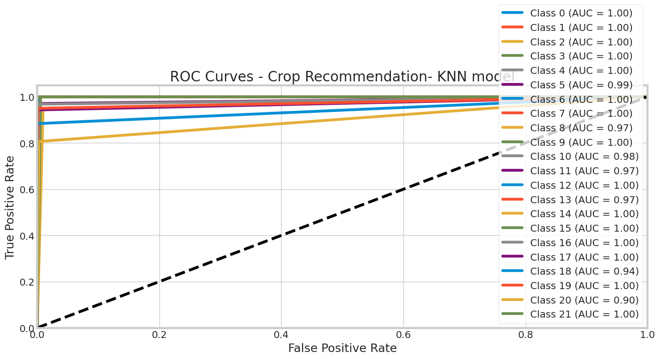
from sklearn.metrics import roc_auc_score
# Compute ROC AUC score for each class separately
roc_auc_scores = roc_auc_score(y_test_bin_knn, y_pred_bin_knn, average=None)
# Print the ROC AUC scores for each class
print("the ROC AUC scores for each class")
print(roc_auc_scores)
the ROC AUC scores for each class
[1. 1. 0.99932432 1. 1. 0.98529412
0.9986413 1. 0.96819808 0.99725652 0.98251779 0.97142857
1. 0.97431507 1. 1. 1. 1.
0.94186047 1. 0.90187263 1. ]

Logistic Regression
# Create a logistic regression classifier object
lm = LogisticRegression(random_state=2)
# Fit the model on the train set
lm.fit(X_train, y_train)
# Evaluate the model
print('Accuracy_decision_tree:', lm.score(X_test, y_test))
# Perform prediction on the test set
y_pred_lm = lm.predict(X_test)
# Calculate the accuracy of the model
score_test_lm= lm.score(X_test, y_test)
score_train_lm= lm.score(X_train, y_train)
print("Accuracy Train_lm:", score_train_lm)
print("Accuracy Test_lm:", score_test_lm)
#print("Predictions_lm:", y_pred_lm)
print(classification_report(y_test,y_pred_lm))
Accuracy_decision_tree: 0.9493506493506494
Accuracy Train_lm: 0.9734265734265735
Accuracy Test_lm: 0.9493506493506494
precision recall f1-score support
0 1.00 1.00 1.00 42
1 0.97 1.00 0.98 32
2 0.76 0.83 0.79 30
3 1.00 1.00 1.00 42
4 1.00 1.00 1.00 36
5 0.97 1.00 0.99 34
6 0.86 0.91 0.89 34
7 1.00 1.00 1.00 29
8 0.84 0.86 0.85 37
9 1.00 1.00 1.00 41
10 0.88 0.94 0.91 31
11 0.90 0.80 0.85 35
12 0.97 1.00 0.99 37
13 0.94 0.82 0.88 40
14 0.94 1.00 0.97 34
15 1.00 1.00 1.00 28
16 1.00 1.00 1.00 29
17 0.95 0.92 0.94 39
18 0.98 0.95 0.96 43
19 1.00 1.00 1.00 41
20 0.90 0.84 0.87 31
21 1.00 1.00 1.00 25
accuracy 0.95 770
macro avg 0.95 0.95 0.95 770
weighted avg 0.95 0.95 0.95 770
/usr/local/lib/python3.10/dist-packages/sklearn/linear_model/_logistic.py:458: ConvergenceWarning: lbfgs failed to converge (status=1):
STOP: TOTAL NO. of ITERATIONS REACHED LIMIT.
Increase the number of iterations (max_iter) or scale the data as shown in:
https://scikit-learn.org/stable/modules/preprocessing.html
Please also refer to the documentation for alternative solver options:
https://scikit-learn.org/stable/modules/linear_model.html#logistic-regression
n_iter_i = _check_optimize_result(
# Calculate the confusion matrix
cm_lm = confusion_matrix(y_test, y_pred_lm)
# Calculate the precision, recall, and accuracy
precision_lm = precision_score(y_test, y_pred_lm, average='macro')
recall_lm = recall_score(y_test, y_pred_lm, average='macro')
accuracy_lm = accuracy_score(y_test, y_pred_lm)
# Print the confusion matrix, precision, recall, and accuracy
print('Confusion Matrix_lm:\n', cm_lm)
print('Precision_lm:', precision_lm)
print('Recall_lm:', recall_lm)
print('Accuracy_lm:', accuracy_lm)
Confusion Matrix_lm:
[[42 0 0 0 0 0 0 0 0 0 0 0 0 0 0 0 0 0 0 0 0 0]
[ 0 32 0 0 0 0 0 0 0 0 0 0 0 0 0 0 0 0 0 0 0 0]
[ 0 0 25 0 0 0 0 0 0 0 4 0 0 1 0 0 0 0 0 0 0 0]
[ 0 0 0 42 0 0 0 0 0 0 0 0 0 0 0 0 0 0 0 0 0 0]
[ 0 0 0 0 36 0 0 0 0 0 0 0 0 0 0 0 0 0 0 0 0 0]
[ 0 0 0 0 0 34 0 0 0 0 0 0 0 0 0 0 0 0 0 0 0 0]
[ 0 0 0 0 0 0 31 0 0 0 0 3 0 0 0 0 0 0 0 0 0 0]
[ 0 0 0 0 0 0 0 29 0 0 0 0 0 0 0 0 0 0 0 0 0 0]
[ 0 0 0 0 0 1 0 0 32 0 0 0 0 0 0 0 0 2 0 0 2 0]
[ 0 0 0 0 0 0 0 0 0 41 0 0 0 0 0 0 0 0 0 0 0 0]
[ 0 0 1 0 0 0 0 0 0 0 29 0 0 1 0 0 0 0 0 0 0 0]
[ 0 1 0 0 0 0 5 0 1 0 0 28 0 0 0 0 0 0 0 0 0 0]
[ 0 0 0 0 0 0 0 0 0 0 0 0 37 0 0 0 0 0 0 0 0 0]
[ 0 0 5 0 0 0 0 0 0 0 0 0 0 33 2 0 0 0 0 0 0 0]
[ 0 0 0 0 0 0 0 0 0 0 0 0 0 0 34 0 0 0 0 0 0 0]
[ 0 0 0 0 0 0 0 0 0 0 0 0 0 0 0 28 0 0 0 0 0 0]
[ 0 0 0 0 0 0 0 0 0 0 0 0 0 0 0 0 29 0 0 0 0 0]
[ 0 0 0 0 0 0 0 0 0 0 0 0 1 0 0 0 0 36 1 0 1 0]
[ 0 0 2 0 0 0 0 0 0 0 0 0 0 0 0 0 0 0 41 0 0 0]
[ 0 0 0 0 0 0 0 0 0 0 0 0 0 0 0 0 0 0 0 41 0 0]
[ 0 0 0 0 0 0 0 0 5 0 0 0 0 0 0 0 0 0 0 0 26 0]
[ 0 0 0 0 0 0 0 0 0 0 0 0 0 0 0 0 0 0 0 0 0 25]]
Precision_lm: 0.9484103535190335
Recall_lm: 0.9493509885289815
Accuracy_lm: 0.9493506493506494
# Get the odds ratio
import numpy as np
odds_ratio_lm = np.exp(lm.coef_)
print("Odds Ratio:", odds_ratio_lm) # but this one does not look nice
# Create a pandas dataframe with the variable names and the odds ratio
df_lm = pd.DataFrame({'Variable': ['N','P','K','temperature','humidity','ph','rainfall'], 'Odds Ratio': odds_ratio_lm[0]})
df_lm
Odds Ratio: [[0.54706688 1.40261162 2.72801835 0.80564186 0.82026246 0.94553226
0.75372608]
[1.62968566 1.33366431 1.2239318 0.81684293 0.67031393 0.90433924
1.06477502]
[0.81018652 1.64081691 0.62142228 1.48160552 1.04440934 0.88797258
1.11106599]
[1.02915518 1.40761787 2.0132508 0.96609521 0.54951158 1.0335309
1.00785204]
[0.64193801 0.47632569 0.80849455 0.90161356 1.58229829 0.94351681
1.46562391]
[2.34451706 0.53312356 0.69916986 1.07488448 0.55317443 1.02163897
1.42754932]
[2.10129335 0.82787839 0.47653131 0.80915539 1.11309566 0.97089435
0.98596234]
[0.5764745 1.59135492 3.63918542 0.85486848 0.73938387 0.95954768
0.35104605]
[1.36336015 0.79200149 0.88196633 0.87350147 0.85914282 1.10230331
1.43163539]
[0.76019429 2.18114889 0.90328278 1.00453002 0.40189906 1.06937881
1.36267165]
[0.74933954 2.00069486 0.64320645 0.7599186 1.37943205 1.07212236
0.88564011]
[1.82075103 0.96203335 0.68286139 0.94105798 0.915743 1.04096253
1.11876413]
[0.69212928 0.85252403 1.47912397 2.1259296 0.98062588 1.10943184
1.1809776 ]
[0.73853598 1.29812 0.89945789 2.62994627 0.90513018 1.5603967
1.04399779]
[0.72717373 1.07014827 0.58783979 0.96840781 2.1088007 0.9751173
0.88362629]
[2.08371985 0.6044716 1.17322022 1.09684311 1.54911625 1.00017127
0.29612427]
[0.64685527 0.56928179 0.48781037 1.00683425 1.94393341 1.05274712
1.30586486]
[0.73067269 1.10922861 1.81185082 0.82848698 1.16311756 0.7440502
1.2036141 ]
[0.74647734 1.63243086 0.5581216 1.09541957 0.9102132 0.95270124
1.3981877 ]
[0.67237821 0.63955075 1.57411187 0.85042112 1.74137561 1.03482555
1.08972846]
[1.33641653 0.77371077 0.82001999 0.56844143 0.83976336 0.82442368
1.58230844]
[2.1250722 0.5698299 1.19456676 0.96205731 1.15579466 1.00346904
0.65026465]]
Variable Odds Ratio
0 N 0.547067
1 P 1.402612
2 K 2.728018
3 temperature 0.805642
4 humidity 0.820262
5 ph 0.945532
6 rainfall 0.753726
####################################
# ROC Curve Construction
####################################
# compute TPR = True Positive Rate and FPR=False Positive Rate for various thresholds
# Binarize the output
y_test_bin_lm = label_binarize(y_test, classes=[0 ,1 ,2 ,3 ,4 ,5 ,6 ,7 ,8 ,9 ,10 ,11 ,12 ,13 ,14 ,15 ,16 ,17 ,18 ,19 ,20 ,21])
y_pred_bin_lm= label_binarize(y_pred_lm, classes=[0 ,1 ,2 ,3 ,4 ,5 ,6 ,7 ,8 ,9 ,10 ,11 ,12 ,13 ,14 ,15 ,16 ,17 ,18 ,19 ,20 ,21])
# compute ROC curve and AUC for each class
fpr = dict()
tpr = dict()
roc_auc = dict()
num_classes = y_test_bin_lm.shape[1] # Get the number of classes in your problem
for i in range(num_classes):
fpr[i], tpr[i], _ = roc_curve(y_test_bin_lm[:, i], y_pred_bin_lm[:, i])
roc_auc[i] = auc(fpr[i], tpr[i])
# plot ROC curves
plt.figure()
for i in range(num_classes):
plt.plot(fpr[i], tpr[i], label='Class %d (AUC = %0.2f)' % (i, roc_auc[i]))
plt.plot([0, 1], [0, 1], 'k--') # diagonal line for reference
plt.xlim([0.0, 1.0])
plt.ylim([0.0, 1.05])
plt.xlabel('False Positive Rate')
plt.ylabel('True Positive Rate')
plt.title('ROC Curves - Crop Recommendation- Logistic Rg model')
plt.legend(loc="lower right")
plt.show()
# The ROC curve below shows a near perfect model since the Blue ROC curve is almost touching the top left corner
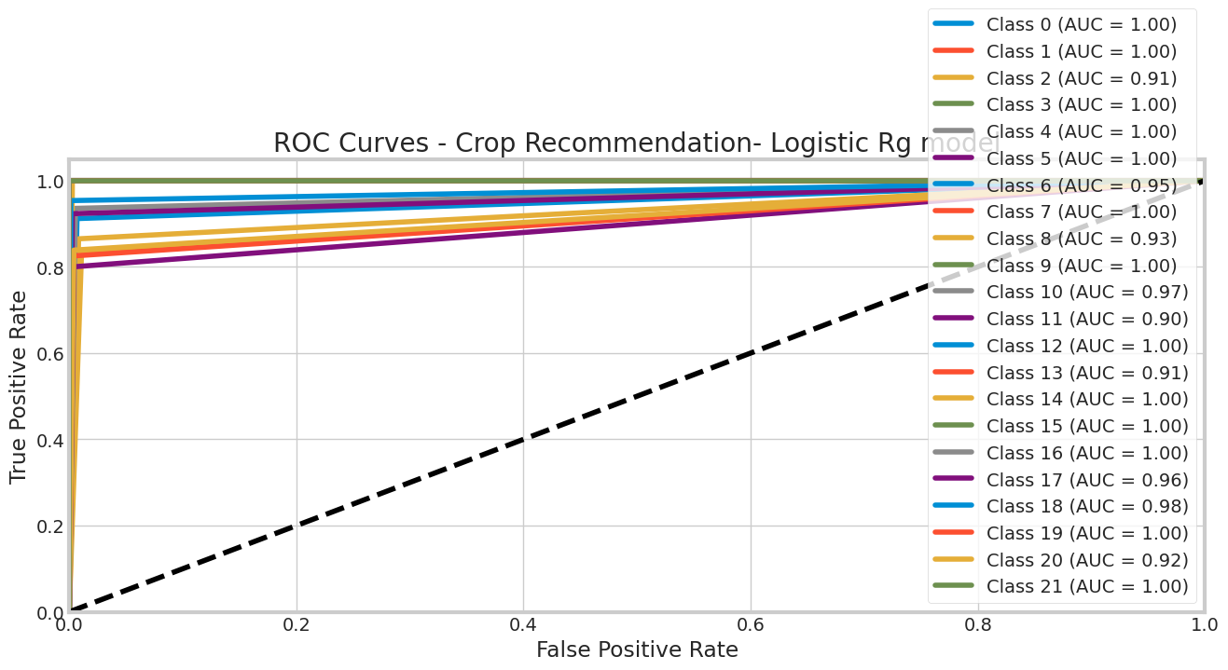
from sklearn.metrics import roc_auc_score
# Compute ROC AUC score for each class separately
roc_auc_scores = roc_auc_score(y_test_bin_lm, y_pred_bin_lm, average=None)
# Print the ROC AUC scores for each class
print("the ROC AUC scores for each class")
print(roc_auc_scores)
the ROC AUC scores for each class
[1. 0.99932249 0.91126126 1. 1. 0.99932065
0.95248561 1. 0.92833966 1. 0.96503558 0.89795918
0.99931787 0.91113014 0.9986413 1. 1. 0.96017047
0.97605643 1. 0.91732507 1. ]

Random Forest
from sklearn.ensemble import RandomForestClassifier
# Build the random forest model
rfc = RandomForestClassifier(n_estimators=100, random_state=10,max_depth=4)
rfc.fit(X_train, y_train)
RandomForestClassifier(max_depth=4, random_state=10)
# Evaluate the model
print('Accuracy_rfc:', rfc.score(X_test, y_test))
# Predict the labels of the test set
y_pred_rfc = rfc.predict(X_test)
# Calculate the accuracy of the model
score_test_rfc = rfc.score(X_test, y_test)
score_train_rfc = rfc.score(X_train, y_train)
print("Accuracy Train_rfc:", score_train_rfc)
print("Accuracy Test_rfc:", score_test_rfc)
#print("Predictions_rfc:", y_pred_rfc)
print(classification_report(y_test,y_pred_rfc))
Accuracy_rfc: 0.9142857142857143
Accuracy Train_rfc: 0.9391608391608391
Accuracy Test_rfc: 0.9142857142857143
precision recall f1-score support
0 1.00 1.00 1.00 42
1 1.00 1.00 1.00 32
2 0.58 1.00 0.73 30
3 1.00 1.00 1.00 42
4 1.00 1.00 1.00 36
5 0.97 1.00 0.99 34
6 1.00 1.00 1.00 34
7 1.00 1.00 1.00 29
8 1.00 0.27 0.43 37
9 1.00 1.00 1.00 41
10 0.65 1.00 0.78 31
11 1.00 1.00 1.00 35
12 1.00 1.00 1.00 37
13 1.00 0.25 0.40 40
14 1.00 1.00 1.00 34
15 1.00 1.00 1.00 28
16 1.00 1.00 1.00 29
17 1.00 1.00 1.00 39
18 1.00 0.79 0.88 43
19 1.00 1.00 1.00 41
20 0.54 1.00 0.70 31
21 1.00 1.00 1.00 25
accuracy 0.91 770
macro avg 0.94 0.92 0.91 770
weighted avg 0.95 0.91 0.90 770
import matplotlib.pyplot as plt
# Get the feature importances from the trained model
feature_importances = rfc.feature_importances_
# Get the names of the features/columns from your dataset
feature_names = X_train.columns
# Sort the feature importances and corresponding feature names in descending order
sorted_indices = feature_importances.argsort()[::-1]
sorted_importances = feature_importances[sorted_indices]
sorted_feature_names = feature_names[sorted_indices]
# Create a bar plot to visualize the feature importances
plt.figure(figsize=(10, 6))
plt.bar(range(X_train.shape[1]), sorted_importances, tick_label=sorted_feature_names)
plt.xticks(rotation=90)
plt.xlabel('Features')
plt.ylabel('Importance')
plt.title('Feature Importances from Random Forest Classifier')
plt.tight_layout()
plt.show()
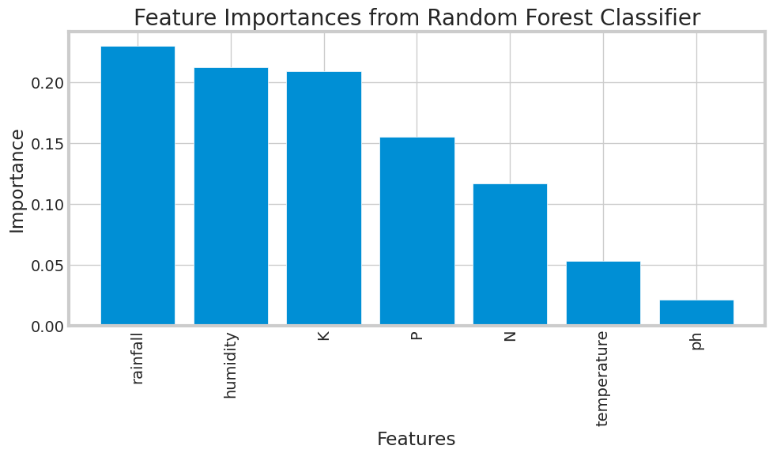
# Calculate the confusion matrix
cm_rfc = confusion_matrix(y_test, y_pred_knn)
# Calculate the precision, recall, and accuracy
precision_rfc = precision_score(y_test, y_pred_rfc, average='macro')
recall_rfc = recall_score(y_test, y_pred_rfc, average='macro')
accuracy_rfc = accuracy_score(y_test, y_pred_rfc)
# Print the confusion matrix, precision, recall, and accuracy
print('Precision_rfc:', precision_rfc)
print('Recall_rfc:', recall_rfc)
print('Accuracy_rfc:', accuracy_rfc)
Precision_rfc: 0.9426383923094451
Recall_rfc: 0.9232258156676761
Accuracy_rfc: 0.9142857142857143

Comapring the Accuracies for all the models
print("*******************************************")
print("********* Accuracy during Training ********")
print("*******************************************")
print(" ")
print("Accuracy Accuracy Train_decision_tre:", score_train_decision_tree)
print("Accuracy Train_knn. :", score_train_knn)
print("Accuracy Train_lm. :", score_train_lm)
print("Accuracy Train_rfc:", score_train_rfc)
print(" ")
print("*******************************************")
print("********* Accuracy during Testing ********")
print("*******************************************")
print(" ")
print("Accuracy Test_Accuracy Train_decision_tree:", score_test_decision_tree)
print("Accuracy Test_knn. :", score_test_knn)
print("Accuracy Test_lm :", score_test_lm)
print("Accuracy Test_rfc:", score_test_rfc)
print(" ")
print("*******************************************")
print("********* Accuracy for model ********")
print("*******************************************")
print(" ")
print('Accuracy_decision_tress:', accuracy_decision_tress)
print('Accuracy_knn:', accuracy_knn)
print('Accuracy_lm:', accuracy_lm)
print('Accuracy_rfc:', accuracy_rfc)
print(" ")
print("*******************************************")
print("********* Precision ********")
print("*******************************************")
print(" ")
print('Precision_decision_tress:', precision_decision_tress)
print('Precision_knn:', precision_knn)
print('Precision_lm:', precision_lm)
print('Precision_rfc:', precision_rfc)
print(" ")
print("*******************************************")
print("********* Recall ********")
print("*******************************************")
print(" ")
print('Recall_decision_tress:', recall_decision_tress)
print('Recall_knn:', recall_knn)
print('Recall_lm:', recall_lm)
print('Recall_rfc:', recall_rfc)
*******************************************
********* Accuracy during Training ********
*******************************************
Accuracy Accuracy Train_decision_tre: 0.9311688311688312
Accuracy Train_knn. : 0.9888111888111888
Accuracy Train_lm. : 0.9734265734265735
Accuracy Train_rfc: 0.9391608391608391
*******************************************
********* Accuracy during Testing ********
*******************************************
Accuracy Test_Accuracy Train_decision_tree: 0.9121212121212121
Accuracy Test_knn. : 0.9753246753246754
Accuracy Test_lm : 0.9493506493506494
Accuracy Test_rfc: 0.9142857142857143
*******************************************
********* Accuracy for model ********
*******************************************
Accuracy_decision_tress: 0.9121212121212121
Accuracy_knn: 0.9753246753246754
Accuracy_lm: 0.9493506493506494
Accuracy_rfc: 0.9142857142857143
*******************************************
********* Precision ********
*******************************************
Precision_decision_tress: 0.9386549113061836
Precision_knn: 0.9770188965753482
Precision_lm: 0.9484103535190335
Precision_rfc: 0.9426383923094451
*******************************************
********* Recall ********
*******************************************
Recall_decision_tress: 0.9151562148558813
Recall_knn: 0.975786627396221
Recall_lm: 0.9493509885289815
Recall_rfc: 0.9232258156676761
import matplotlib.pyplot as plt
import seaborn as sns
import numpy as np
# Accuracy scores from the results
train_accuracy = [0.9311688311688312, 0.9888111888111888, 0.9714285714285714, 0.9391608391608391]
test_accuracy = [0.9121212121212121, 0.9753246753246754, 0.9606060606060606, 0.9142857142857143]
# Models for plotting
models = ['Decision Tree', 'k-Nearest Neighbors', 'Logistic Regression', 'Random Forest']
# Create x-axis positions for the bars
x_pos = np.arange(len(models))
# Choose colors for training and testing bars
train_color = 'cornflowerblue'
test_color = 'lightcoral'
# Set seaborn style
sns.set_style('whitegrid')
# Create a bar plot for training accuracy and testing accuracy
plt.figure(figsize=(10, 6))
plt.bar(x_pos, train_accuracy, width=0.4, label='Training Accuracy', color=train_color)
plt.bar(x_pos + 0.4, test_accuracy, width=0.4, label='Testing Accuracy', color=test_color)
plt.xlabel('Models')
plt.ylabel('Accuracy')
plt.ylim(0.85, 1.0) # Adjust the y-axis limits based on your accuracy range
plt.title('Training and Testing Accuracy of Different Models')
plt.legend()
plt.xticks(x_pos + 0.2, models, rotation=45, ha='right')
plt.tight_layout()
plt.show()
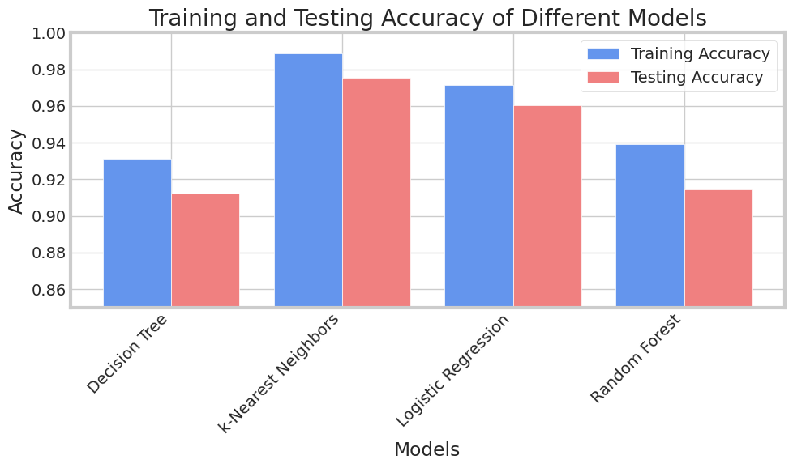

Real Time Prediction
crop_recom.head()
N P K temperature humidity ph rainfall label
0 90 42 43 20.879744 82.002744 6.502985 202.935536 rice
1 85 58 41 21.770462 80.319644 7.038096 226.655537 rice
2 60 55 44 23.004459 82.320763 7.840207 263.964248 rice
3 74 35 40 26.491096 80.158363 6.980401 242.864034 rice
4 78 42 42 20.130175 81.604873 7.628473 262.717340 rice
prediction = decision_tree.predict((np.array([[75, 35, 10, 25.468, 62,5.7,200]])))
print("The Suggested Crop for Given Input Data is :", prediction)
The Suggested Crop for Given Input Data is : ['maize']
/usr/local/lib/python3.10/dist-packages/sklearn/base.py:439: UserWarning: X does not have valid feature names, but DecisionTreeClassifier was fitted with feature names
warnings.warn(

